**Protocol for Find and Replace Program**

Given a series, the program will rename any set of objects that contains a certain set of characters.

1. If Python is not already installed on your computer, download the latest version for Windows at <https://www.python.org/downloads/>
   1. Run the EXE file that is downloaded. The installer screen should then pop up:

Please ensure that “Add Python [version] to PATH” is checked – it is not checked by default. After confirming this, click on “Install Now.”

* 1. Once the installation has finished, a message saying “Setup was successful” will be displayed. At this point, you can close the window. Python is now successfully installed on your computer.

1. Download the Python code from <https://github.com/julian-falco/ExtractESynapseData> by clicking on the green button that says “Code” and clicking “Download ZIP.” The program will be downloaded as a zipped folder.

1. Open the zipped folder and run the Python file (FindAndReplace.py)
   1. You can do this by double-clicking the file.
   2. Feel free to extract the contents of the zipped folder and/or run the program in IDLE.
2. Once the program starts running it will ask for the following:
   1. The file path for the folder containing the series
      1. You will need to find the folder containing the Reconstruct files in your file explorer and copy the file path (circled in red below):

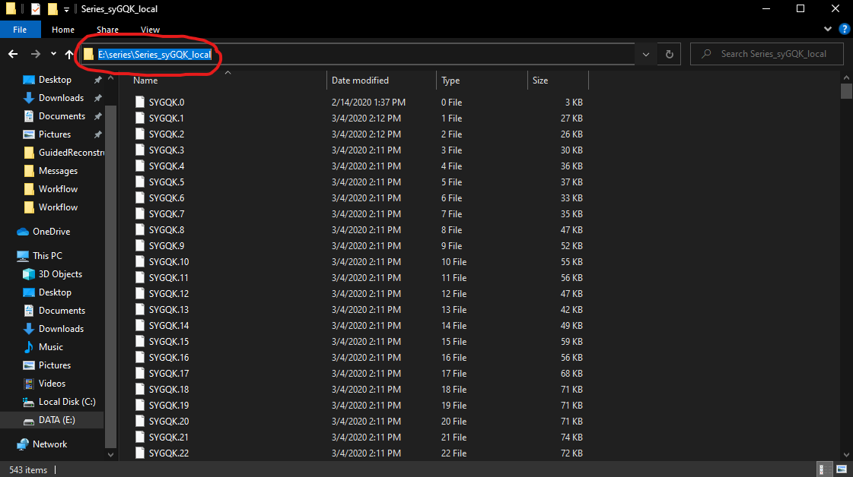

Paste this exact path into the program.

* 1. The name of the series
     1. The program assumes that the files will all be named after the series name
  2. The number of sections in the series
     1. Include the 0 section; for example, if there are sections 0-200 in a series, then there are 201 sections.
  3. The character set you want to search for (ex. d013)
  4. The character set you would like to replace it with (ex. d001)
  5. Whether or not you wish to replace all instances of the search query
     1. If not, you are given the option to replace the search query at each instance

1. At this point, the program should start running and printing every instance of the search query. After it finishes, it will ask for one more confirmation before the object names in the trace files are re-written. After the program finishes, you should receive a message saying that it has run successfully.